FMSCUG Driver Installer

# Usage Documentation - Version 1.2.2.0

1. **Settings:**

Settings for the driver installer application are set and stored in an info.diconfig file that needs to be present in the same directory as the executable (typically, the package root directory). Upon launch, the driver installer will read settings from the info.diconfig file and apply them to the running instance of the application. If this file is not present, defaults are used. Settings are set in this diconfig file one per line and with the following syntax: **<SettingName>=<Setting>**

**Current Settings Available:**

* CompanyName (default: “CompanyName=FMSCUG”)
* InstallersScriptsAreNamed (default: “InstallerScriptsAreNamed=install.cmd”)

1. **Usage:**
   1. **Implementation:** Implementation of the Driver Installer is fairly straightforward. Upon Launch, the executable will search its currently running directory for any subdirectories containing scripts with the filename set in the “InstallerScriptsAreNamed” setting within the info.diconfig file. When these are found, their paths are added to a list, which the driver installer will call one by one within a new shell process, waiting for each to complete before moving on to the next one.
   2. **Usage within OSD:** The Driver Installer can be utilized within task sequences by being included in a source package and called from a command line step. Each source package should include the driver installer executable, the info.diconfig file containing any settings you want, ProcessUI.exe (from the Microsoft Deployment Toolkit), as well as a subfolder for each driver installer containing the installer sources and an installation script to silently install them.
      1. *You must call The Driver Installer executable from ProcessUI.exe, otherwise it will run, but not show, during task sequences.*
      2. *The source directory of the created package should look like the following:*

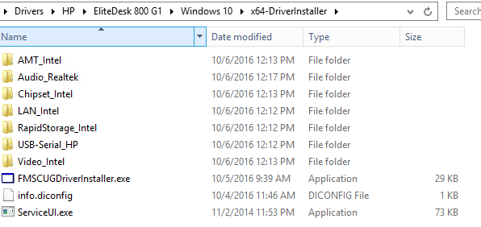

* 1. **Scripting Driver Installers:** Most Driver installation EXEs can be scripted to install Silently. Many will even have a readme, which will list the EXE to call to install the driver, as well as either switches available for the installer, or a switch to run against the installer that will list available switches (EX: setup.exe /? Or setup.exe -? May show available command line options). For example, take the Intel Chipset Installer for an HP notebook:
* Download the chipset driver EXE from HP.
* Use an archive tool like 7-Zip to extract the contents of the EXE into a subfolder (This Subfolder becomes the source folder for this driver (you could name this folder “Chipset_Intel”)).
* Create a blank file named “install.cmd” within the driver’s source folder
* Edit the install.cmd file to silently run the driver’s installer, you can include logging if you wish and if available for the particular installer in question.

*Note: If you include logging, you should add a mkdir statement at the beginning of your script to ensure that the log’s root path is present so that you can avoid error due to a non-existent log destination.*